Holocaust memorabilia found on eBay
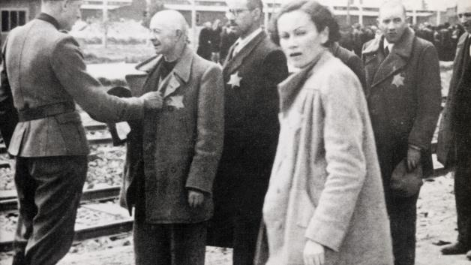Getty Images: Imagno, Austrian Archives.
Victims at the Auschwitz concentration camp in 1944.

U.K. newspaper The Mail on Sunday said its reporters found a range of items on the site over the past week, including clothes worn by concentration camp victims.
LONDON — EBay has removed from its listings around 30 items of memorabilia from the Nazi Holocaust, including clothes worn by concentration camp victims, after a newspaper investigation discovered they were on sale on the e-commerce website, Britain's Mail on Sunday said.
The newspaper said its reporters found a range of items on the site over the past week, including what was presented by the vendor as a complete Auschwitz uniform worn by a Polish baker who perished in the Nazi death camp.
The Mail on Sunday said it had alerted eBay and that the online auctioneer had removed 30 items from sale and offered to make a donation of $40,000 to a suitable charity.
In a statement, eBay said: "We are very sorry these items have been listed on eBay and we are removing them. We don't allow listings of this nature, and dedicate thousands of staff to policing our site and use the latest technology to detect items that shouldn't be for sale.
"We very much regret that we didn't live up to our own standards. We have made a donation to charity to reflect our concern," said the company, which receives a commission on items sold and charges vendors a listing fee.
The Mail on Sunday said eBay had been unable to say how long such items may have been for sale on its website.
The paper said the purported Auschwitz uniform had been priced at 11,300 sterling by the vendor, a Ukrainian man based in Canada, who had sold another batch of clothing purporting to be linked to Auschwitz for $18,000 last year.
The report quoted the vendor, named as Viktor Kempf, as saying he had been criticized in the past for selling such items, but did so to "document" them and to fund history book projects.
"I don't want people to think I'm just doing it for the money. These periods in history are horrific, nobody should ever forget them," Kempf was quoted as saying.
Other items found on eBay by the British paper included shoes and a toothbrush said to have belonged to concentration camp victims as well as yellow Star of David armbands used by the Nazis to identify Jews for persecution.
Additional reporting by Jennifer Ablan in New York

